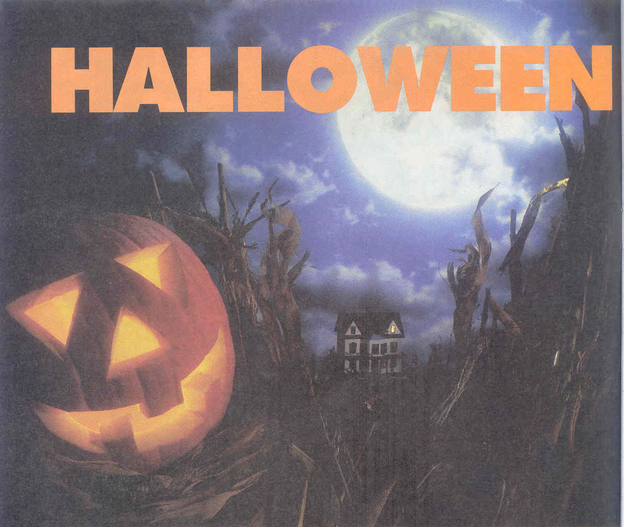

“HALLOWEEN”

СЦЕНАРИЙ ПРАЗДНИКА

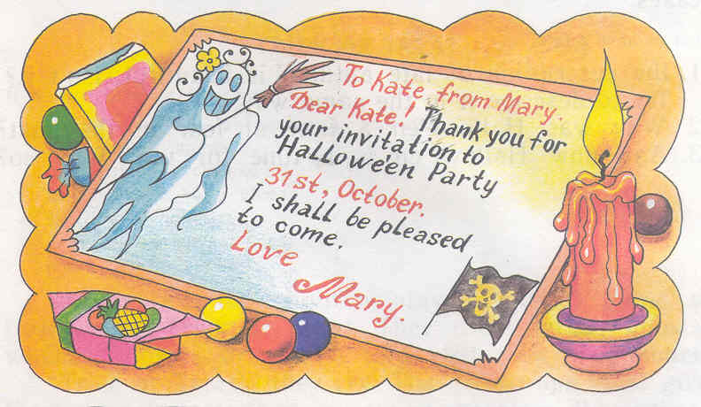
В класс заходят несколько учащихся. Они приглашают друг друга и гостей на праздник (зачитывают и обмениваются приглашениями).

To Lena from Sasha.
I’m going to have a Halloween on the 31st of October.
I’m going to invite you. You’ll be beauty.

To Mary from Kate.
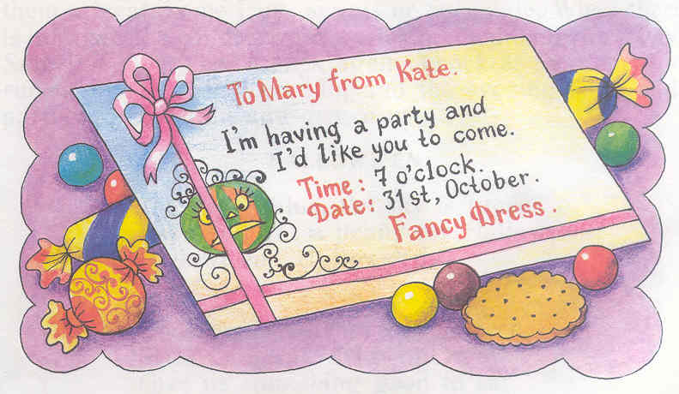
I’m having a party and I’d like you to come.
Time: 7 o’clock.
Date: 31st, October.
Fancy Dress.

Thank you for your invitation to Halloween Party.

Открывается дверь класса и заходят дети в карнавальных костюмах с фонариками, сделанными из тыкв, арбузов, грейпфрутов. Они обходят учащихся и гостей со словами:

The sky is blue, the sky is green,
Have you got a penny
For Halloween,
Halloween, Halloween.
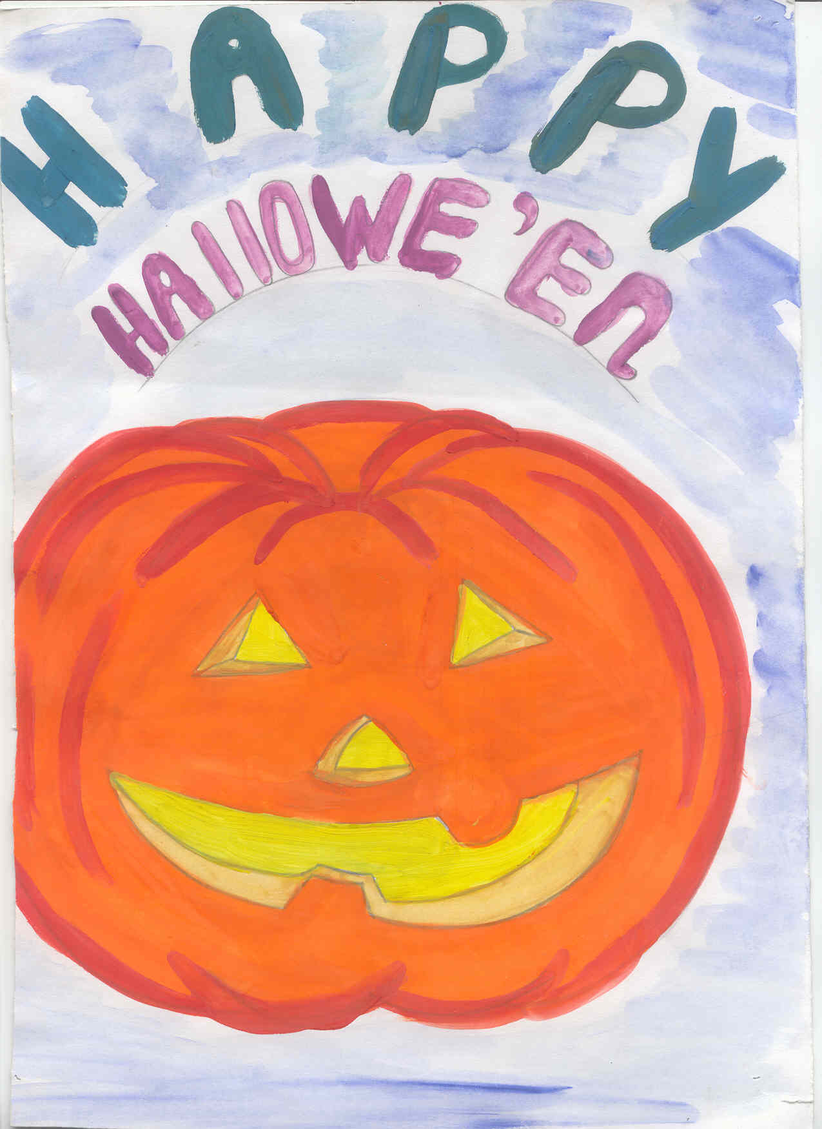
Ghosts and witches can be seen.
Trick or Treat, Trick or Treat!
Give us something good to eat!

Give us candy, give us cake,
Give us something sweet to take.

Give us cookies, fruit and gum,
Hurry up and give us some.

You had better do it quick
Or we’ll surely play a trick!

Trick or treat, trick or treat,
Give us something good to eat!
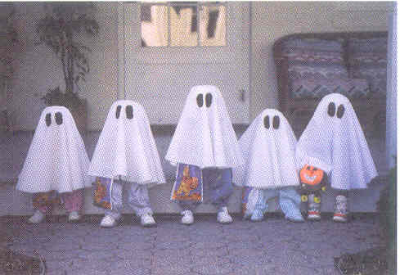
Today’s the day!
Tonight’s the night!
We won the game.
Halloween is my name!

Гости дают детям угощение:
конфеты, фрукты, сладости.

Затем учащиеся рассказывают о празднике Halloween.

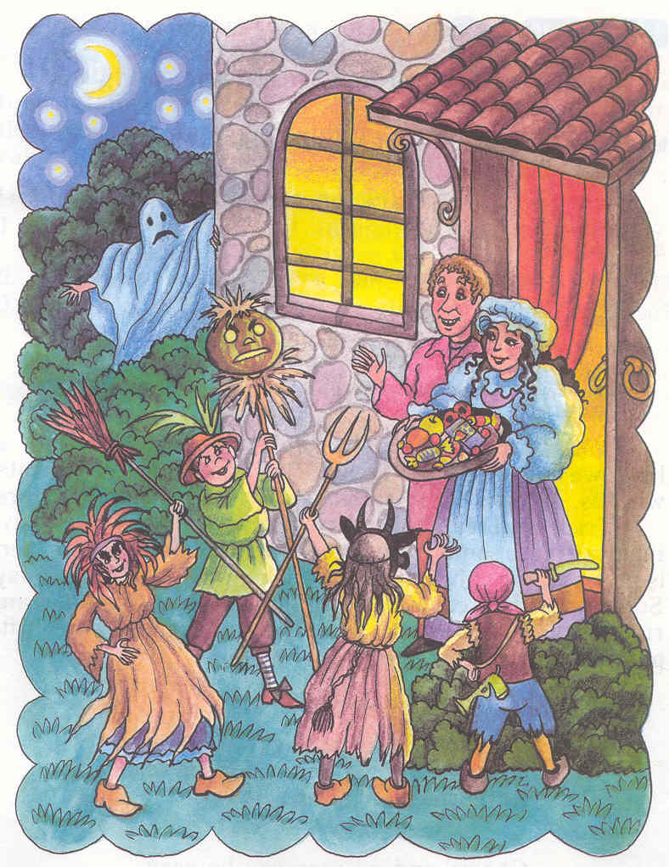
1-й ученик:

Halloween is a festival that takes place on October 31st. In United States the children play a special game at Halloween: Trick or Treat. They dress up as ghosts, witches, clowns or pirates and visit their neighbours.

2-й ученик:

They also decorate houses and schools in traditional Halloween colours: orange and black. Many of them carve jack-o-lanterns out of pumpkins. Fortunetelling and storytelling about ghosts and witches are popular activities.
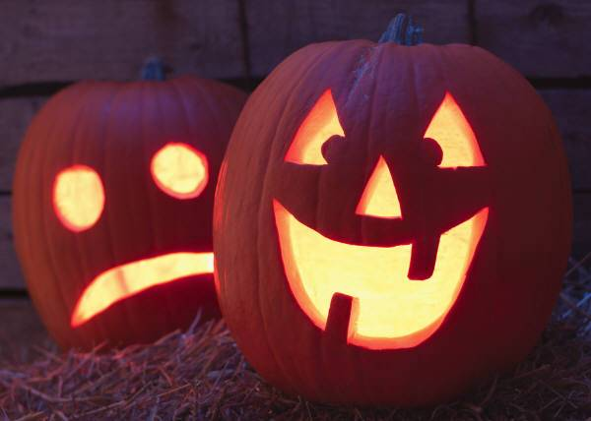
3-й ученик:
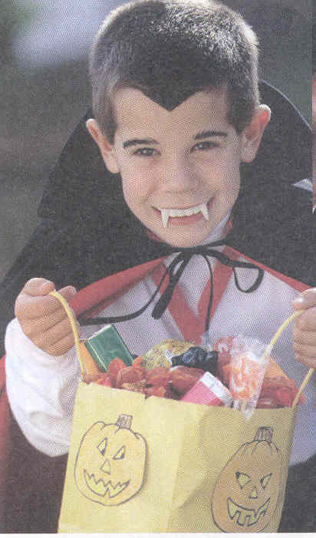
The main Halloween activity for children is trick-or-treating. Children dress in costumes and masks and go from door to door saying “trick or treat”. The neighbours give children such treats as candy, fruit and pennies so that children do not play tricks on them.

4-й ученик:

Popular decorations are witches, ghosts skeletons, black cats and jack-o’-lanterns. Jack-o’-lanterns are hallowed-out pumpkins with face carved into one side. Most jack-o’-lanterns contain a candle inside. Everyone tries to look scary on Halloween.

Five Little Pumpkins sitting on a gate.
The first one said, “Oh my, it’s getting late’.
The second one said, “There are witches in the air.”
The third one said, ”But we don’t care.”
The fourth one said, ”Let’s run and run and run!”
The fifth one said, “I’m ready for some fun!”
Oooooooo went the wind and out went the light,
And the five little pumpkins rolled out of sight…

5-й ученик:

Fortunetelling is an important part of Halloween. For example, a coin, a ring and a thimble were baked into a cake. It was believed that the person who found the coin would become wealthy. The one who found the ring would marry soon. And the person who found the thimble would never married. Today people practice cardreading or palmistry.
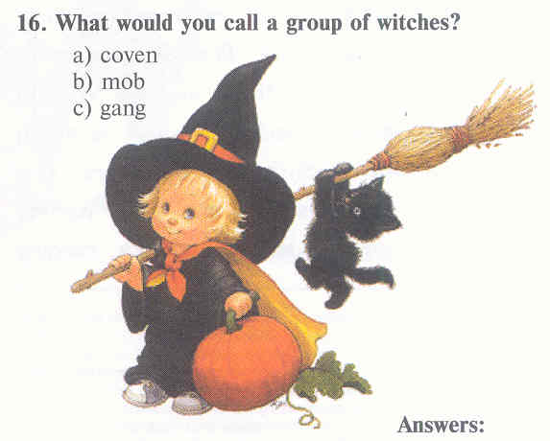
6-й ученик:

People once believed that there were many ghosts and witches on the Earth and that they met on October 31 to worship the devil. Today, people do not believe in ghosts and witches but they like to tell stories about them on Halloween.

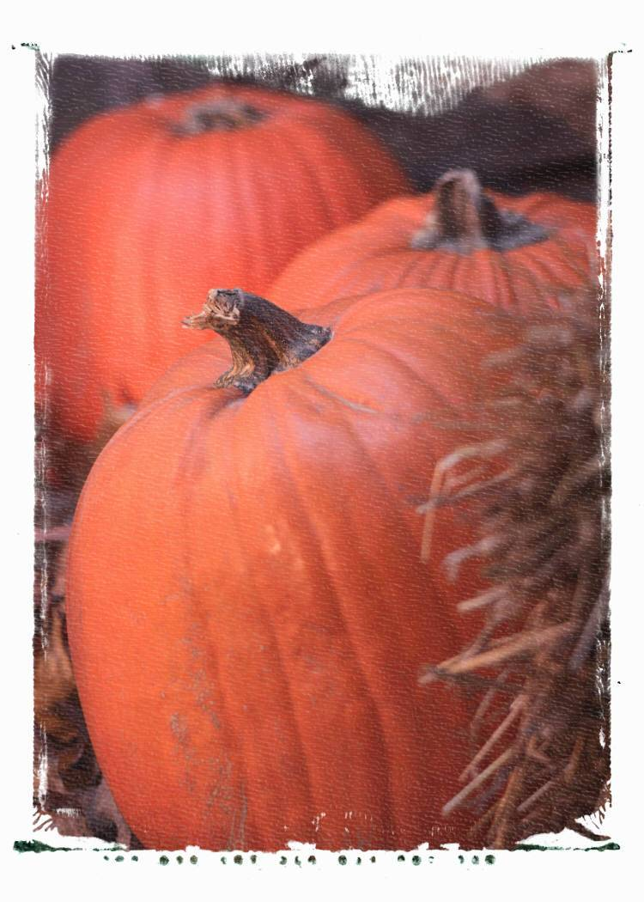
The Witch
There once was a witch of Willoughby wood;
And a weird wild witch was she;
With her hair that was snarled,
And hands that were gnarled,
And a rickety, kickety knee.
She could jump they say
To the moon and back,
But this I never did see.

Witch, witch, where do you fly?
Under the clouds and over the sky.
Witch, witch, what do you eat?
Little black apples from Hurricane Street.
Witch, witch, what do you drink?
Vinegar and good red ink.
Witch, witch, where do you sleep?
Up in the clouds where the pillows are cheap.

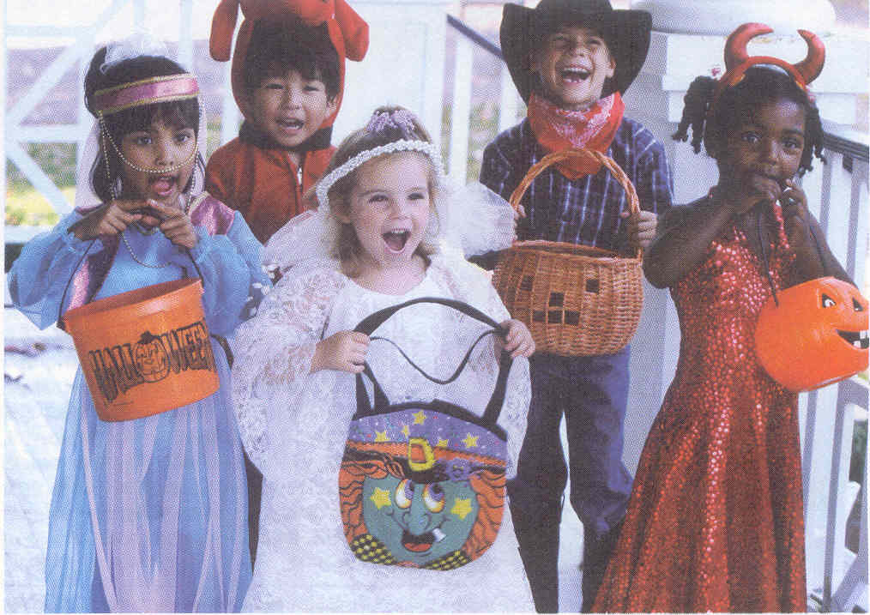
После рассказа о празднике начинается игровая программа.

. Учитель просит детей: «Children, take some sheets of paper and coloured pencils and listen to the commands»:

1.Draw a small house in the middle..
2. Colour the house brown.
3. Colour the roof red.
4. The house has two windows
And a door.
5. There are flowers near the house.
6. Drow a tree to the right of the house.
7. Write your name.
8. Give the pictures to me.

Главным критерием в оценке рисунка является правильность выполнения команд.
Победитель получает приз.

А теперь несколько загадок:
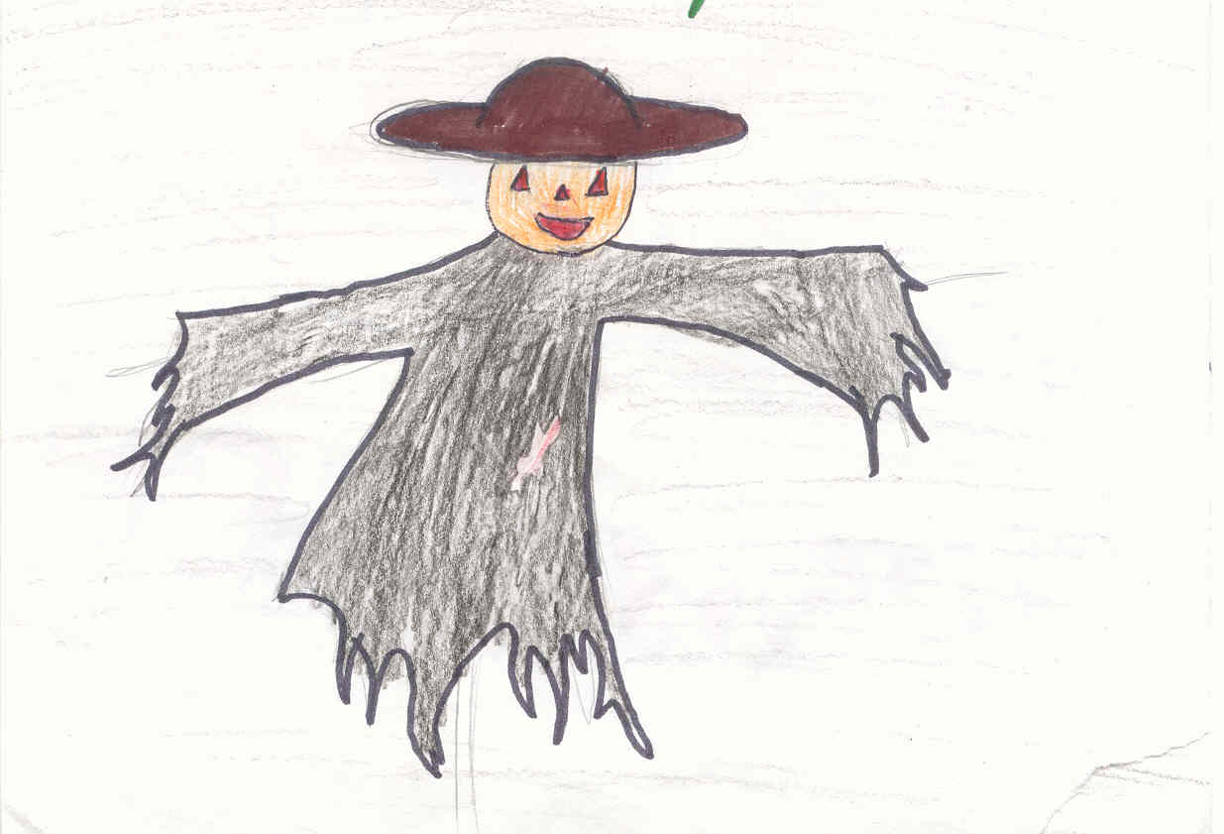
Riddles:

Something big and something small,
But always round and yellow.
When children make my famous grin
Then I’m a scary fellow.
(Jack-o-lantern)

The teacher writes on me with chalk.
My face is green, I cannot talk.
(a blackboard)

In winter and in summer
They stand in one colour.
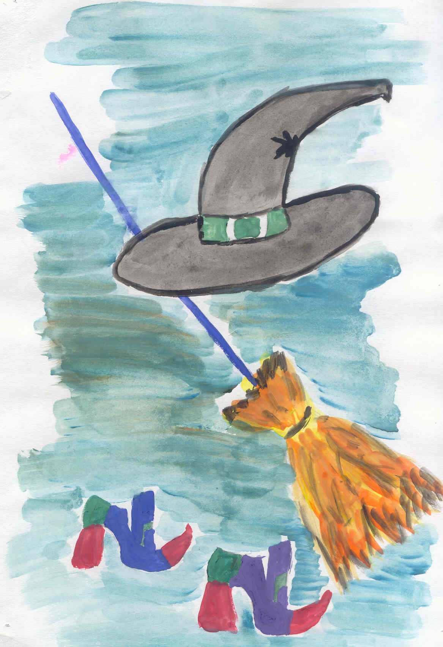
(a fir-tree, a pine-tree)

A little old man with 12 children:
Some are short, some are long,
Some are cold, some are hot.
What is it?
(a year)

I can tell you all the day
Time to sleep and time to play.
(a clock)

I come with cold and snow
But you like me, I know.
(winter)

Ученик, отгадавший больше всех загадок, получает приз.

Затем дети играют в подвижные игры.

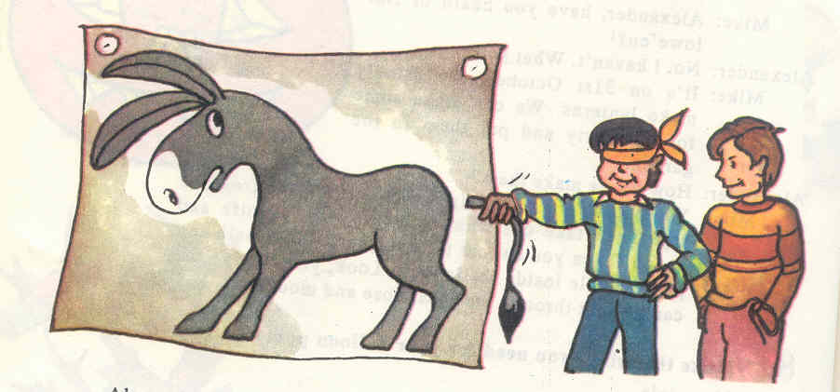

The game “Pin the Tail on the Donkey” is one of the most popular.

First you must put the poster on the wall. Then everybody has chance to pin the tail on the donkey. It’s not easy because you cannot see. You have a scarf over your eyes. The person who puts the tail nearest to the right place is the winner.

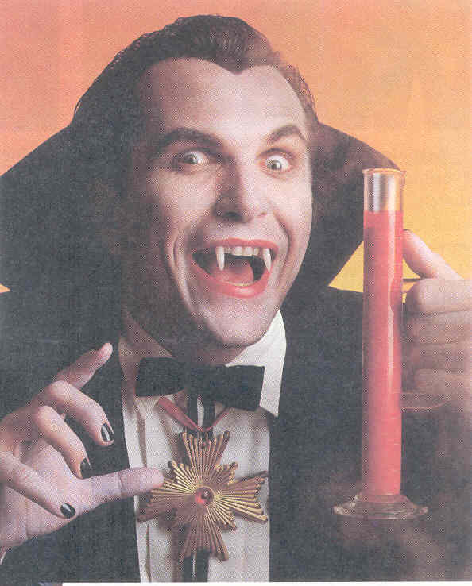

Another game is bobbing for apples. One child at a time has to get apples from a tub of water without using hands! How? By sinking his or her face into the water and biting the apple!

Победители получают призы.

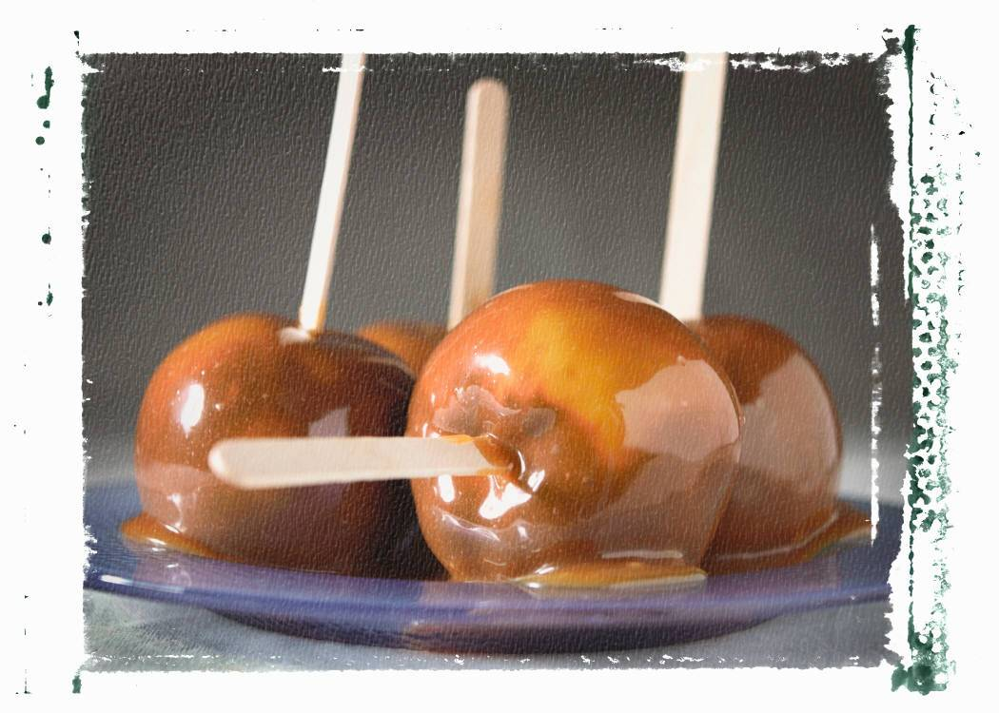

Halloween Treats

Caramel Apples: Takes the paper wrapping off 100 caramels and put them in a saucepan. Put the saucepan over a pan of boiling water. Boil the water until the caramels melt. Put a wooden stick into the top of each apple, did the apple into the caramel. Let them cool on wax paper and enjoy!

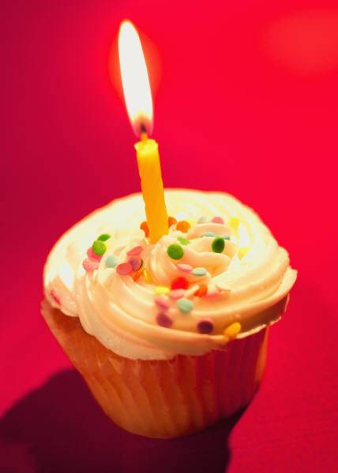
Pumpkin Seeds: Collect pumpkin seeds after carving you pumpkin, separate the pulp from the seeds. Rinse the seeds and spread them out to dry. The next day, add enough melted butter or margarine to coat each seed. Spread the seeds into a cookie sheet and bare for 20 minutes in a 300 degree oven for 20 minutes or until they are slightly brown.

Popcorn Balls: Combine ½ cup of corn syrup, a teaspoon of vinegar and ½ teaspoon of salt in a saucepan. Heat to 250 degrees Fahrenheit or until a small spoonful of the mixture forms a hard ball when dropped into the
water.
Remove from heat and add 1 teaspoon of vanilla. Put warm popped corn in a large greased bowl. Slowly pour the syrup over the popcorn, tossing with a greased fork until mixed thoroughly. Be careful, it’s hot! When it’s cool enough to handle, butter your hands and shape popped corn into 3-inch balls. Place on waxed paper until cool and no longer sticky, then wrap in waxed paper.

HALLOWE’EN SOUNDS

This is the way the witches fly, witches fly, witches fly,
This is the way the witches fly,
Swish, swish, swish.

This is the way the ghosts go by, ghosts go buy, ghosts go by,
This is the way the ghosts go by,
Oooh, oooh, oooh.

This is the way the black cats howl, black cats howl, black cats howl,
This is the way the black cats howl,
Meow! Meow! Meow!

This is the way the pumpkin laugh, pumpkin laugh, pumpkin laugh,
This is the way the pumpkin laugh,
Hee! Hee! Hee

This is the way the night owls cry, night owls cry, night owls cry,
This is the way the night owls cry,
Hoo, hoo, hoo.

Праздник заканчивается угощением и танцами.

